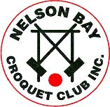 | NELSON BAY CROQUET CLUB  inaugural  CHRISTMAS BUSH BASH 2022 | 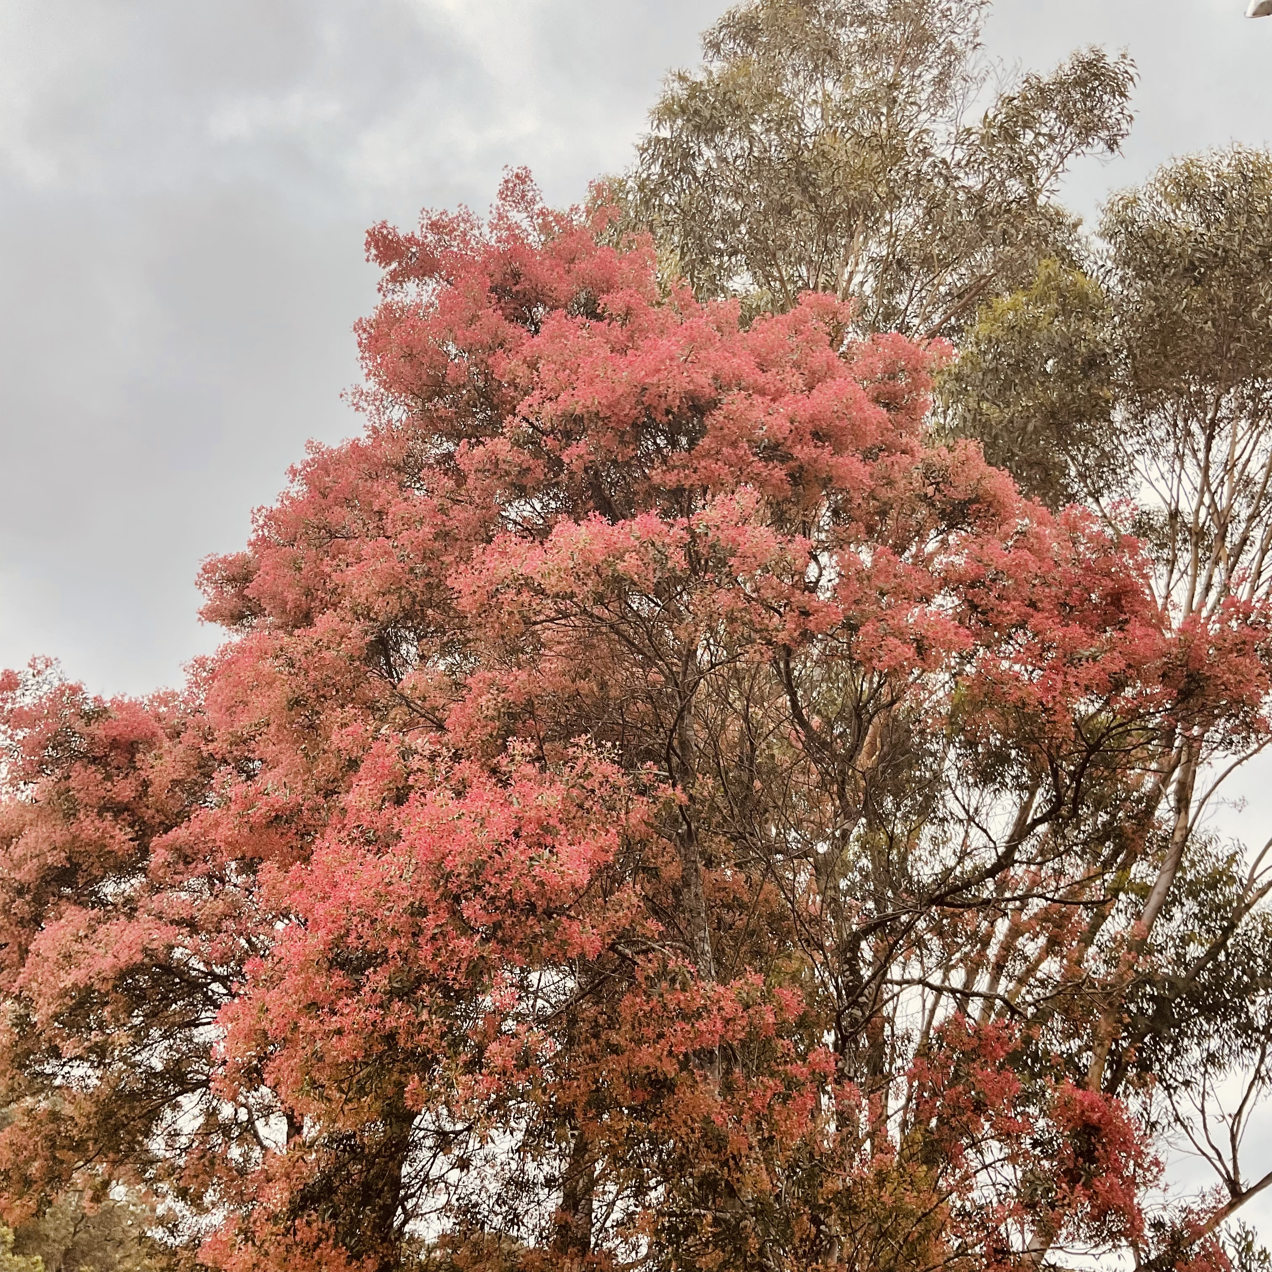
Golf Croquet Open Doubles Tournament
Saturday 19th November to Monday 21st November
Entry Form
Player 1  Name ………………………  Address ………………………  ………………………  Club ………………………  Phone ………………………  Email ………………………  ACA Id ………………………  Hdp/Index ………/……………  Are you available to referee? Yes / No | Player 2  Name ………………………  Address ………………………  ………………………  Club ………………………  Phone ………………………  Email ………………………  ACA Id ………………………  Hdp/Index ………/……………  Are you available to referee? Yes / No

Post completed entry form with entry fee $45pp (cheques should be made payable to Nelson Bay Croquet Club Inc)
OR
email completed entry form to nelsonbaycroquet@gmail.com and pay entry fee $45pp by direct debit to 650 000 Account Number 954989200 (please advise names on the transfer)
Nelson Bay Croquet Club  PO Box 332  Nelson Bay 2315 | nelsonbaycroquet@gmail.com  https://www.nelsonbaycroquet.org.au

